1. Grade Checker
First, I used the input() function to take marks from the user. Since input is taken as text, I converted it into an integer using int() so that I can compare the marks numerically.
Then, I used if-elif-else conditions to check the range of marks:
- If the marks are greater than or equal to 90, it prints Grade A
- If the marks are between 80 and 89, it prints Grade B
- If the marks are between 70 and 79, it prints Grade C
- If the marks are between 60 and 69, it prints Grade D
- If the marks are below 60, it prints a fail message
The program checks each condition step by step and prints the correct grade based on the input.

🖥️ Output Explanation:
From the screenshot:
- When input is 95, output is → Grade A
- When input is 24, output is → Failed
- When input is 73, output is → Grade C
This shows that the program is correctly assigning grades based on different inputs.

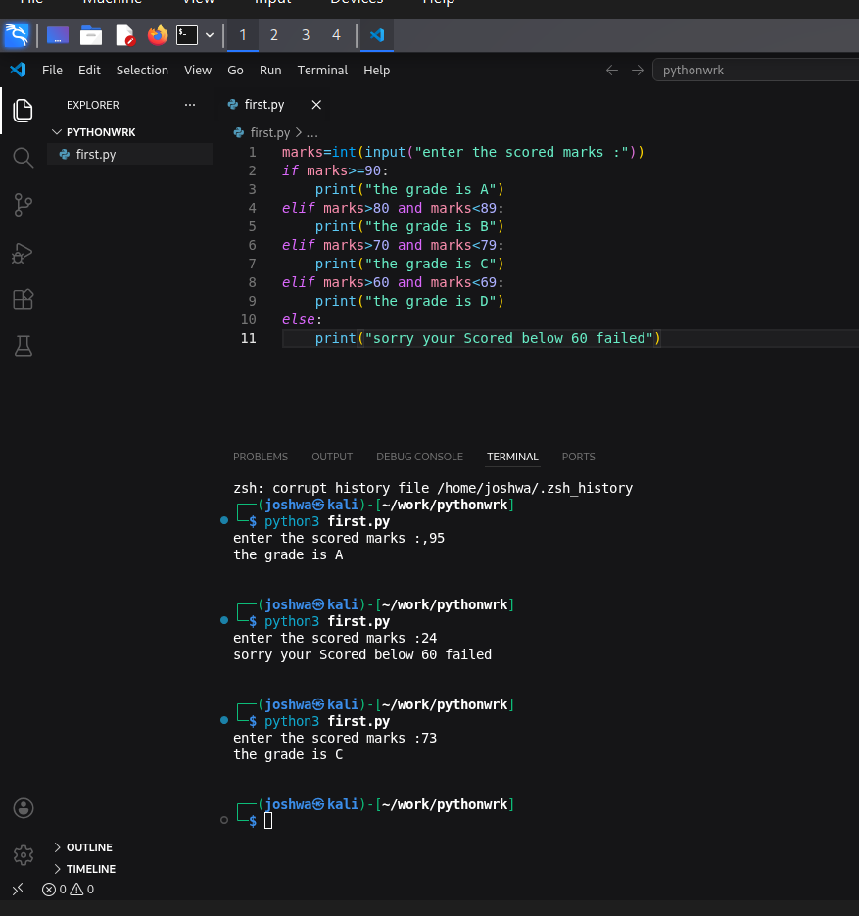

2 Student Grades
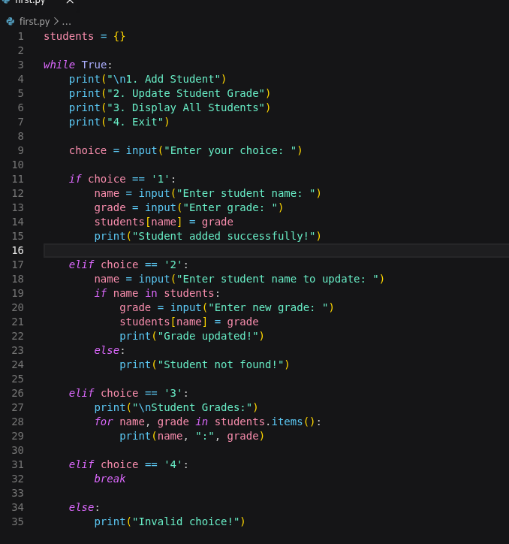

Output
┌──(joshwa㉿kali)-[~/work/pythonwrk]
└─$ python3 first.py

1. Add Student
2. Update Student Grade
3. Display All Students
4. Exit
Enter your choice: 1
Enter student name: sania
Enter grade: a
Student added successfully!

1. Add Student
2. Update Student Grade
3. Display All Students
4. Exit
Enter your choice: 1
Enter student name: josh
Enter grade: b
Student added successfully!

1. Add Student
2. Update Student Grade
3. Display All Students
4. Exit
Enter your choice: 1
Enter student name: kim
Enter grade: a
Student added successfully!

1. Add Student
2. Update Student Grade
3. Display All Students
4. Exit
Enter your choice: 2
Enter student name to update: kim'
Student not found!

1. Add Student
2. Update Student Grade
3. Display All Students
4. Exit
Enter your choice: 2
Enter student name to update: kim
Enter new grade: d
Grade updated!

1. Add Student
2. Update Student Grade
3. Display All Students
4. Exit
Enter your choice: 3

Student Grades:
sania : a
josh : b
kim : d

1. Add Student
2. Update Student Grade
3. Display All Students
4. Exit
Enter your choice:
3.Write to a File
4. Read from a File
